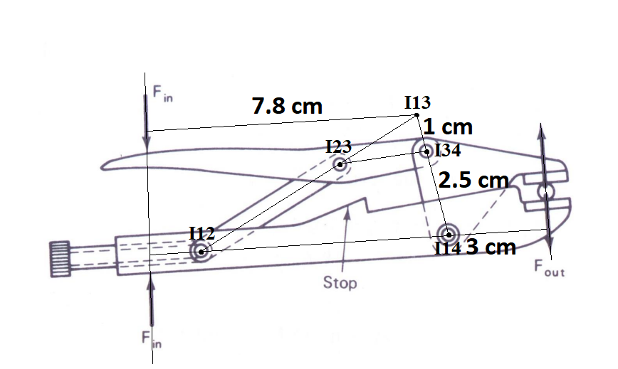
$$V_{I_{in,out}}=ω_{3}\left(I_{13}→I_{34}\right)=ω_{4}\left(I_{14}→I_{34}\right)$$
$$\frac{ω_{3}}{ω_{4}}=\frac{I_{14}→I_{34}}{I_{13}→I_{34}}$$
$$Power In=Power Out$$
$$\left(r_{in}*F_{in}\right)\left(ω_{3}\right)=\left(-r_{out}*F_{out}\right)\left(-ω_{4}\right)$$
$$M.A=\frac{F_{out}}{F_{in}}=\frac{r_{in}*ω_{3}}{r_{out}*ω_{4}}=\frac{r_{in}}{r_{out}}*\frac{I_{14}→I_{34}}{I_{13}→I_{34}}13$$
$$F_{out}=M.A.*F_{in}$$

